- MAP COLORING
AIM
To write a Python program to implement Map Coloring using Constraint Satisfaction Problem (CSP).
OBJECTIVE
- To understand the concept of CSP.
- To assign colors to different regions.
- To ensure that adjacent regions have different colors.
- To find a valid map-coloring solution using backtracking.
ALGORITHM
- Start.
- Enter the number of regions, region names, and available colors.
- Enter the neighboring regions for each region.
- Select a region and try each available color.
- Check whether the selected color conflicts with any neighboring region.
- If there is no conflict, assign the color.
- Use backtracking if a conflict occurs.
- Repeat until all regions are colored.
- Display the solution.
- Stop.

FLOWCHART:
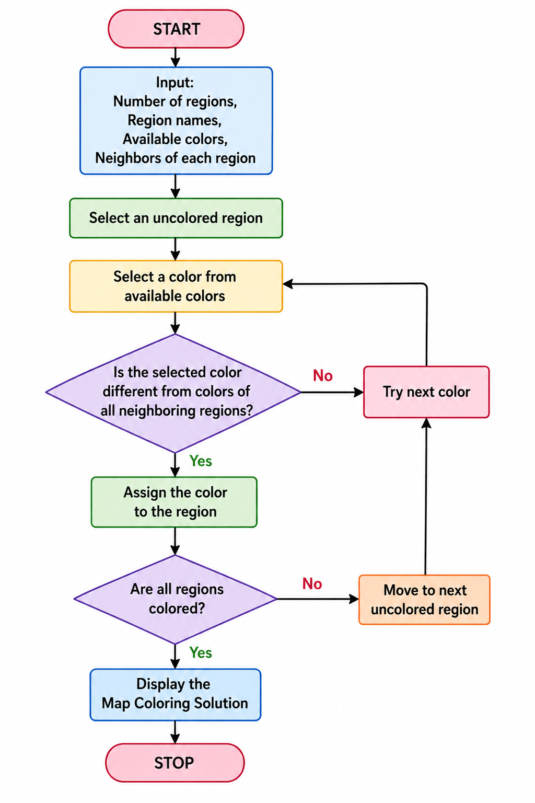
PYTHON CODE:
# Map Coloring using CSP
n = int(input("Enter number of regions: "))
regions = input("Enter region names: ").split()
colors = input("Enter colors: ").split()
adj = {}
for r in regions:
adj[r] = input(f"Enter neighbors of {r}: ").split()
sol = {}
def solve(i):
if i == n:
return True
r = regions[i]
for c in colors:
if all(sol.get(x) != c for x in adj[r]):
sol[r] = c
if solve(i + 1):
return True
del sol[r]
return False
if solve(0):
print("\nMap Coloring:")
for r in regions:
print(r, "->", sol[r])
else:
print("No solution")
OUTPUT:
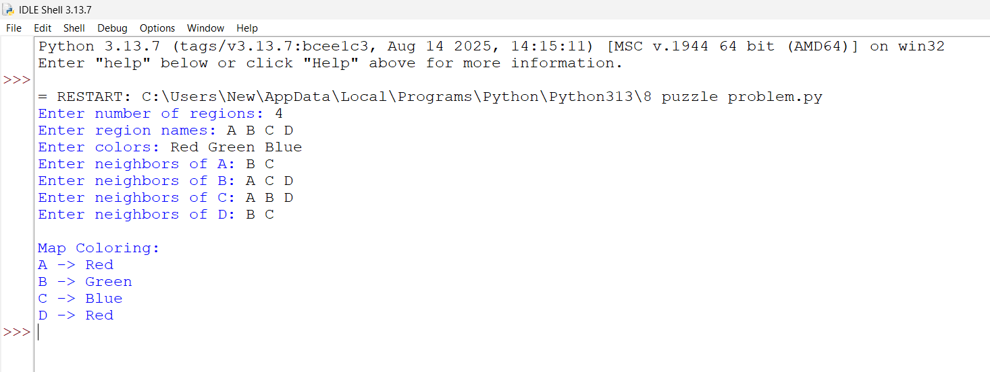
RESULT:
Thus, the Map Coloring problem was successfully implemented using CSP and backtracking, ensuring that adjacent regions are assigned different colors.

